|  |  |
| --- | --- |
|  | |
| |  |  |  | | --- | --- | --- | | |  | | --- | | **More virtualization resources** | | [Server virtualization support](http://searchsystemschannel.techtarget.com/resources/Server-Virtualization-Hardware-Software-and-Services) | | | http://cdn.ttgtmedia.com/images/spacer.gif |
| http://cdn.ttgtmedia.com/images/spacer.gif | |

Virtual machine configurations are stored as files with a .vmx extension.The VMX file is just a text file with specific fields that define the virtual machine's configuration.A very short vmx file only needs 14 lines to support a virtual machine that encompasses one [CPU](http://searchsmb.techtarget.com/sDefinition/0,,sid44_gci213867,00.html), one hard drive, and one network adapter.You could create a VMX file with just three lines but it would be of minimalvalue. Code Listings 4.1 and 4.2 show sample VMX configurations.

**Code Listing 4.1** ESX 2.x VMX Code

guestOS = "winnetenterprise"

config.version = "6"

virtualHW.version = "3"

scsi0.present = "true"

scsi0.sharedBus = "none"

scsi0.virtualDev = "lsilogic"

memsize = "512"

scsi0:0.present = "true"

scsi0:0.fileName = "ESX Created VM.vmdk"

scsi0:0.deviceType = "scsi-hardDisk"

ethernet0.present = "true"

ethernet0.allowGuestConnectionControl = "false"

ethernet0.networkName = "VM Network"

ethernet0.addressType = "vpx"

**Code Listing 4.2** ESX 3.x VMX Code

guestOS = "winnetenterprise"

config.version = "8"

virtualHW.version = "4"

scsi0.present = "true"

scsi0.sharedBus = "none"

scsi0.virtualDev = "lsilogic"

memsize = "512"

scsi0:0.present = "true"

scsi0:0.fileName = "ESX Created VM.vmdk"

scsi0:0.deviceType = "scsi-hardDisk"

ethernet0.present = "true"

ethernet0.allowGuestConnectionControl = "false"

ethernet0.networkName = "VM Network"

ethernet0.addressType = "vpx"

As you can tell from Code Listings 4.1 and 4.2, the only difference is in the values of the config.version and virtualHW.version entries.These values relate to the version of ESX Server you are running.To check the values for these fields, open up an existing virtual machine's configuration file in a text editor.

**Code Listing 4.3** VMware Autogenerated VMX Entry Examples

uuid.bios = "56 4d ee 3c 52 06 a3 de-be 4a 73 9c cc 79 25 2b "

ethernet0.generatedAddress = "00:50:56:a7:42:e2"

powerType.powerOff = "default"

powerType.powerOn = "default"

powerType.suspend = "default"

powerType.reset = "default"

**Creating Your Virtual Machine Configuration File**

You now have a basic understanding of how a virtual machine configuration file is constructed and are ready to build your own.The steps that follow detail how to create a new virtual machine configuration file.

* Log in locally or connect to your ESX server remotely.
* Log in with an ID that has root privileges (see the Tip in the previous section), as shown in Figure 4.1.

**Figure 4.1** Gaining Root Level Access on ESX Server

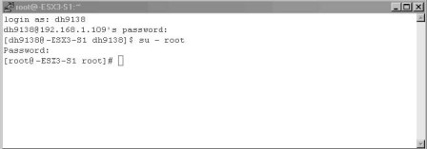

* Change to the location of where you want to put your new virtual machine.Virtual machine configuration files (VMX) have to be stored in the same location as the other virtual machine files (VSWP, VMDK, and so on). See Figure 4.2.

**Figure 4.2** Virtual Machine Storage Location

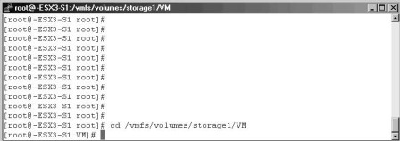

* Create a new directory to store your new virtual machine in newvm and change to that directory (see Figure 4.3).

**Figure 4.3**Virtual Machine Working Directory

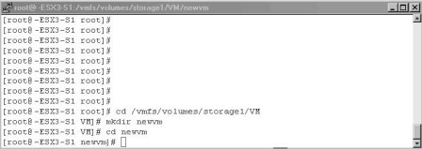

* You are now ready to create your new virtual machine configuration file.We are going to use the built-in text editor VI to create our configuration file.Type **vi newvm.vmx** and press **Enter** (see Figure 4.4).

**Figure 4.4** Creating a New Virtual Machine Configuration File in VI

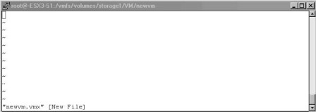

* Press I to turn on inserting (you will see the word insert at the bottom of the screen).
* Type in the following example virtual machine configuration file (see Code Listing 4.4).

**Code Listing 4.4** Example Virtual Machine Configuration File

config.version = "6"

virtualHW.version = "3"

memsize = "256"

floppy0.present = "false"

displayName = "newVM"

guestOS = "winNetStandard"

ide0:0.present = "TRUE"

ide0:0.deviceType = "cdrom-raw"

ide:0.startConnected = "false"

floppy0.startConnected = "FALSE"

floppy0.fileName = "/dev/fd0"

Ethernet0.present = "TRUE"

Ethernet0.connectionType = "monitor_dev"

Ethernet0.networkName = "VM Network"

Ethernet0.addressType = "vpx"

scsi0.present = "true"

scsi0.sharedBus = "none"

scsi0.virtualDev = "lsilogic"

scsi0:0.present = "true"

scsi0:0.fileName = "newvm.vmdk"

scsi0:0.deviceType = "scsi-hardDisk"

* Press the Esc key to exit the insert mode, then press and hold Shift and press ZZ to save and exit (see Figure 4.5).

**Figure 4.5** Saving the VMX File in VI

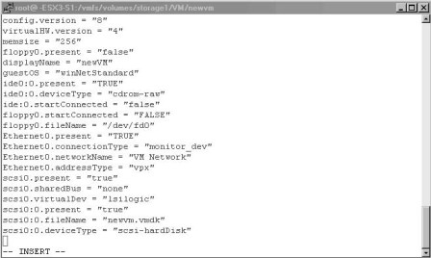

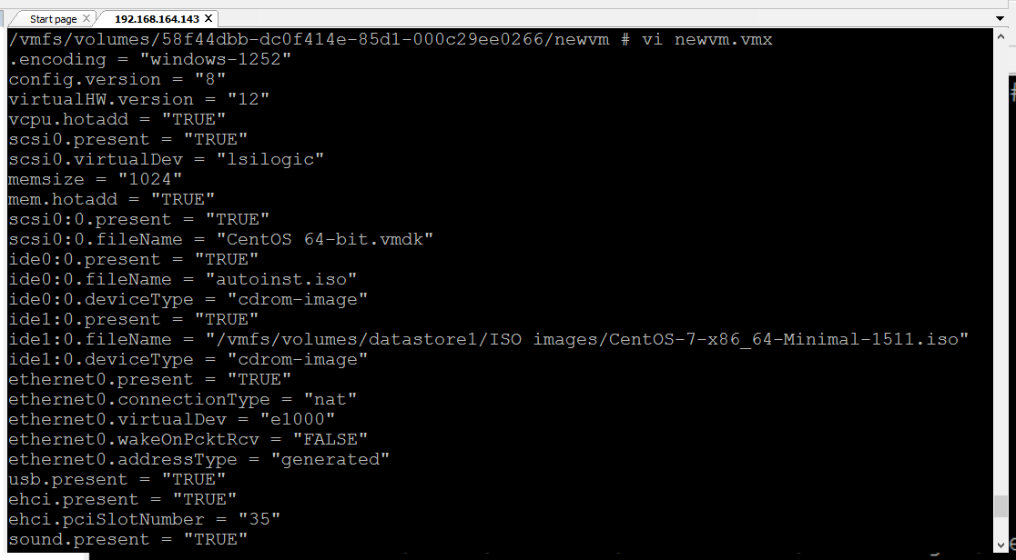

* Type ls –l to get a directory listing.You should now see your new virtual machine configuration file (see Figure 4.6).

**Figure 4.6** Completed Creation of VMX File

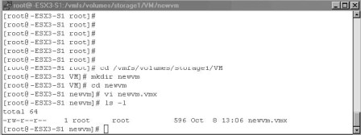

You are now ready to go on to the next section to create the virtual disk newvm.vmdk that you will be referencing in your configuration file.

**Creation of a Virtual Machine Disk File**

VMware has a command-line utility, called *vmkfstools*, which can be used for the creation of VMFS file systems and virtual machine disk files. In this chapter, we will only focus on the options that pertain to virtual disks. For a full listing of command options, type **vmkfstools** in a console session or **man vmkfstools**. Code Listing 4.5 lists the *vmkfstools* options that pertain to virtual disks.

**Code Listing 4.5** *vmkfstools* Command Options for Virtual Disks

vmkfstools

OPTIONS FOR VIRTUAL DISKS:

vmkfstools -c --createvirtualdisk #[gGmMkK]

-d --diskformat [zeroedthick|

eagerzeroedthick|

thick|

thin]

-a --adapterType [buslogic|lsilogic]

-w --writezeros

-j --inflatedisk

-U --deletevirtualdisk

-E --renamevirtualdisk srcDisk

-i --clonevirtualdisk srcDisk

-d --diskformat [rdm:|rdmp:|

raw:|thin|2gbsparse]

-X --extendvirtualdisk #[gGmMkK]

-M --migratevirtualdisk

-r --createrdm /vmfs/devices/disks/...

-q --queryrdm

-z --createrdmpassthru /vmfs/devices/disks/...

-Q --createrawdevice /vmfs/devices/generic/...

-v --verbose #

-g --geometry

vmfsPath

In our example, we will create a 4GB virtual disk called newvm.vmdk and assign it a SCSI LSI Logic adapter. In the console, type the following: **vmkfstools –c 4g newvm.vmdk –a lsilogic.**Then, press **Enter** (see Figure 4.7).

**Figure 4.7 Creating the Virtual Disk**

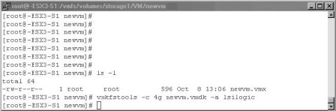

We have now created a virtual disk file newvm.vmdk in the same location as our virtual machine configuration file.The last step is to register this new virtual machine with ESX Server.

**Registering Virtual Machines with ESX Server**

VMware includes the vmware-cmd command tool for performing various operations on virtual machines and the server. In this chapter, we will focus on the virtual machine registration option of this tool *-s register*. For more information on all available tool options, type **vmware-cmd** at the console command prompt.

Type the following all on one line in the console window to register the new virtual machine with the ESX server:

vim-cmd solo/registervm /vmfs/volumes/datastore1/newvm/newvm.vmx

